Chapter 7, Solution 38.

Let i = i_{p} +i_{h}

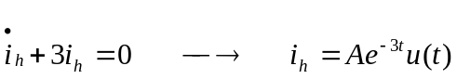

Let 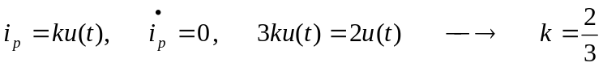
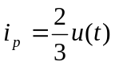

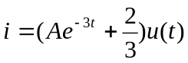

If i(0) =0, then A + 2/3 = 0, i.e. A=-2/3. Thus,

